Standard Impact Assessment Document (SIA)
Please complete electronically and answer all questions unless instructed otherwise.
Section A
Q1: Name of EQIA being completed i.e. name of policy, function etc.
Clackmannanshire & Stirling Health and Social Care Partnership Strategic Commissioning Approach to Dementia
Q1 a; Function Guidance Policy Project Protocol Service Other, please detail
Q2: What is the scope of this SIA
 |  |  |  | Service Specific |  |  |  | Discipline Specific |  |  |  |  |  | Other (Please Detail)
Clackmannanshire & Stirling Health and Social Care Partnership
Older adult mental health services.
Q3: Is this a new development? (see Q1)
Yes |  |  |  |  |  |  |  |  |  |  | No
Q4: If no to Q3 what is it replacing?
Q5: Team responsible for carrying out the Standard Impact Assessment? (please list)
Lisa Powel, Planning and Policy Development Manager, Clackmannanshire & Stirling Health and Social Care Partnership
SLT members
Q6: Main person completing EQIA’s contact details
Name: |  |  | Lisa Powell |  |  |  |  |  |  | Telephone Number:
Department: |  |  | Strategic Planning |  |  |  |  |  |  | Email: |  |  |  |  | Lisa.powell@nhs.scot
Q7: Describe the main aims, objective and intended outcomes
We aim to support people living with dementia to live well within their own communities following diagnosis as well as reducing the amount of time people with dementia spend in a hospital environment.

The Dementia Commissioning Consortium was reconvened in February 2024, with the objective of coming together to review commissioned services for dementia, and review whether the right supports were in place.

The Commissioning Consortium model is grounded in the fundamental principles of ensuring a comprehensive partnership approach across all sectors providing health and social care services; a commitment to provide enhanced delivery of service to individuals and communities and a need to create diversity within the marketplace based on population needs.

In March (2024), the model of care was agreed by consortium members. This Model was developed following initial consultation with service providers. The model of care outlines five levels of support that cover community supports and volunteering opportunities through the levels to more formalised social care supports which someone may need at some point during their dementia journey. These stages are:
- Level 1- Pre diagnostic support and Voluntary opportunities
- Level 2 - Post diagnostic support (PDS)
- Level 3 - Self-Directed and Statutory Supports
- Level 4 - Respite opportunities
- Level 5 - Intensive and palliative supports

The Commissioning Consortium have looked at the agreed levels of support, and discussions regarding the resourcing of these have been a focal point of the meetings. Discussions at subsequent meetings have been based on implementing the model of care moving forward. The model of care breaks service provision down into levels of delivery, attempting to mirror an individual’s dementia journey.

Many discussions have also centred around level 2- post diagnostic support, as PDS is a specific offer to those diagnosed with dementia, good quality post diagnostic support is a priority of the HSCP in order to achieve good outcomes for people diagnosed with dementia, their family, carers and support.

Q8:
(i) Who is intended to benefit from the function/service development/other (Q1) – is it staff, service users or both?
Staff |  |  |  |  | Service Users |  |  |  | Other Please identify - Providers including the third sector
(ii) Have they been involved in the development of the function/service development/other?
Yes |  |  |  |  |  |  | No
(iii) If yes, who was involved and how were they involved? If no, is there a reason for this action?
Comments:

The Dementia Commissioning Consortium, comprising commissioners, third sector leaders, third and independent sector providers, HSCP staff (including Clackmannanshire Council, Stirling Council and NHS colleagues), NHS Acute colleagues, unpaid carers and supported individuals re-commenced in 2023 with a view to working collaboratively to develop an agreed model of care and corresponding sustainable delivery model.

We have heard from those with lived and living experience that being able to access support locally is important, especially as Clackmannanshire and Stirling cover a large geographical area (including significant rurality), having services that are not all based in town / city centres is important. Also having access to choice is aligned to our responsibilities under the Self-Directed Support (Scotland) Act, so commissioning more than one service is key to addressing this requirement.

(iv) Please include any evidence or relevant information that has influenced the decisions contained in this SIA; (this could include demographic profiles; audits; research; published evidence; health needs assessment; work based on national guidance or legislative requirements etc)
Comments:

Graph 1 - Estimated incidence and prevalence of Dementia in Clackmannanshire & Stirling
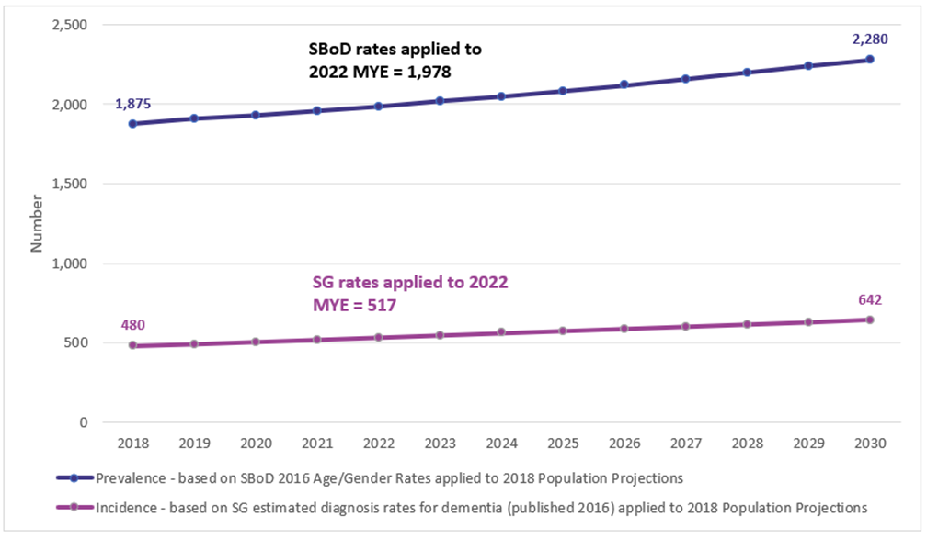
Source: Scottish Burden of Disease 2016; Scottish Government Estimated and projected diagnosis rates for dementia in Scotland 2014-2020: NRS 2022 Mid-Year Population Estimates and 2018-based Population Projections.

Graph 2 – Projected main underlying cause of death associated with palliative care need by disease group up to 2040

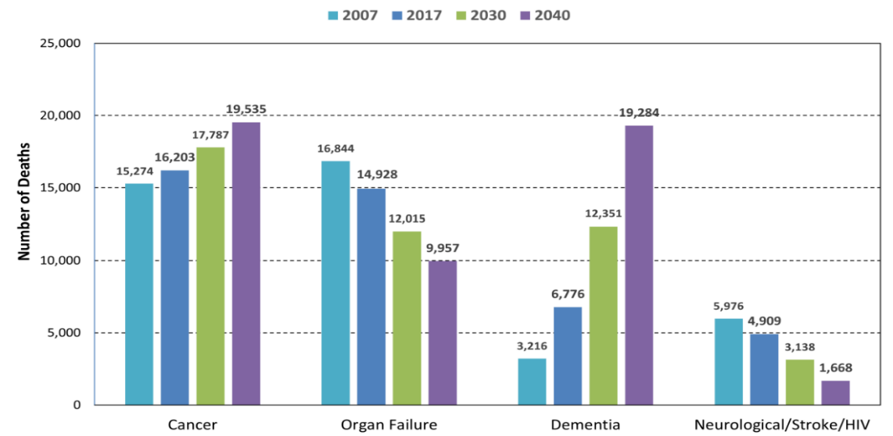
Ref: Finucane AM, Bone AE, Etkind S, et al. How many people will need palliative care in Scotland by 2040? A mixed-method study of projected palliative care need and recommendations for service delivery. BMJ Open 2021;11:e041317. doi:10.1136/ bmjopen-2020-041317

Delivery of one year’s post-diagnostic support to every individual who is diagnosed with dementia is a Local Delivery Plan (LDP) commitment from the Scottish Government, therefore the Clackmannanshire & Stirling IJB is obliged to deliver this support.

Dementia care and support needs to be delivered in a way that is compliant with legislative requirements in terms of choice and control, as set out in the Social Care (Self-directed Support) (Scotland) Act 2013.

Q9: When looking at the impact on the equality groups, you must consider the following points in accordance with General Duty of the Equality Act 2010 see below:
In summary, those subject to the Equality Duty must have due regard to the need to:
- eliminate unlawful discrimination, harassment and victimisation;
- advance equality of opportunity between different groups; and
- foster good relations between different groups
Has your assessment been able to demonstrate the following: Positive Impact, Negative / Adverse Impact or Neutral Impact?
What impact has your review had on the following ‘protected characteristics’: | Positive | Adverse/  Negative | Neutral | Comments  Provide any evidence that supports your conclusion/answer for evaluating the impact as being positive, negative or neutral (do not leave this area blank)
Age | x |  |  | It is anticipated that the Commissioning Approach to Dementia will have a positive impact on older people, their families and carers as the Model of Care has been specifically designed in consultation with people with lived and living experience and various professionals with the specific needs of this group in mind.  Locality Plans in Stirling Rural and Clackmannanshire also specifically define dementia as an agreed priority area.
Disability (incl. physical/ sensory problems, learning difficulties, communication needs; cognitive impairment) | x |  |  | With a focus on ensuring all stages of someone’s progression with dementia are resourced there is an emphasis on improving early intervention, as well as better choice and control, which is expected to have a positive impact.  This approach takes a more holistic approach to the needs of disabled people, as it is clear there are services that can support someone out with commissioned services. The approach is aiming to move towards one which is more aligned with the social model of disability that promotes independence and autonomy and places supported people at the centre of their care / support.
Gender Reassignment |  |  | x | We are anticipating a neutral impact.
Marriage and Civil partnership |  |  | x | We are anticipating a neutral impact.
Pregnancy and Maternity |  |  | x | We are anticipating a neutral impact.
Race/Ethnicity |  |  | x | We are anticipating a neutral impact.
Religion/Faith |  |  | x | We are anticipating a neutral impact.
Sex/Gender (male/female) |  |  | x | We are anticipating a neutral impact.
Sexual orientation |  |  | x | We are anticipating a neutral impact.
Staff (This could include details of staff training completed or required in relation to service delivery) | x |  |  | Members of the HSCP sit on the Commissioning Consortium and have been able to input their thoughts and experiences into the process. Their understanding of how others perceive their service and what else is available in the community will hopefully have a positive impact going forward.

Cross cutting issues: Included are some areas for consideration. Please delete or add fields as appropriate. Further areas to consider in Appendix B
Unpaid Carers |  | x |  |  |  |  | Unpaid carers are represented on the Dementia Commissioning Consortium and have been able to input their views and experiences into the development of the Model of Care.
Language/ Social Origins |  |  |  |  |  | x | This approach focusses on what commissioned services are available at different stages as someone’s needs change. Language and social origins will not change this but should be a consideration as services should be explained to individuals.
Low income/poverty |  |  |  |  |  | x | This approach outlines what commissioned support is available at different stages, it does not focus on someone’s socioeconomic status, and this should not be a barrier to accessing these services.
Mental Health Problems |  | x |  |  |  |  | Better understanding and more equitable resourcing of services relating to dementia will have a positive impact, which can impact upon someone’s mental health and wellbeing.
Rural Areas |  | x |  |  |  |  | We have been told that having services that are not all based in town / city centres is important, to this end any tendering activity can explicitly reference the need to offer services in more rural communities within the HSCP.
Third Sector |  | x |  |  |  |  | Members of the Third Sector are part of the Commissioning Consortium, it is hoped their involvement will increase signposting to services across communities. As well as increasing their knowledge about what else is available and fostering partnership working approaches.
Q10: If actions are required to address changes, please attach your action plan to this document. Action plan attached?
Yes |  |  | No
Q11: Is a detailed EQIA required?
Yes |  |  | No
Please state your reason for choices made in Question 11.

This approach is focused on a specific healthcare condition, dementia, which generally affects people later in life.

A framework of legal rights and duties which underpin dementia as listed below:
- The Equality Act 2010
- Adults with Incapacity (Scotland) Act 2000
- Adult Support & Protection (Scotland) Act 2007
- Mental Health (Care & Treatment) (Scotland) Act 2003
- Carers (Scotland) Act 2016
- Social Care (Self-Directed Support) (Scotland) Act 2013
- Charter of Rights for People with Dementia and their Carers in Scotland 2009
- The Human Rights Act 1998
- The Community Care and Health (Scotland) Act 2002
- Equality Act 2010

N.B. If the screening process has shown potential for a high negative impact you will be required to complete a detailed impact assessment.

Date EQIA Completed | 21/08/2024
Date of next EQIA Review | 21/08/2034
Signature |  | Print Name | Lisa Powell
Department or Service | Strategic Planning

Please keep a completed copy of this template for your own records and attach to any appropriate papers / proposals etc as a record of SIA or EQIA completed.

Send copy to fv.clackmannanshirestirling.hscp@nhs.scot for publication once approved.

B: Standard/Detailed Impact Assessment Action Plan
Name of document being EQIA’d:

Date | Issue | Action Required | Lead (Name, title, and contact details) | Timescale | Resource Implications | Comments

Further Notes:

Signed: |  | Date:

