Standard Impact Assessment Document (SIA)
Please complete electronically and answer all questions unless instructed otherwise.
Section A
Q1: Name of EQIA being completed i.e. name of policy, function etc.
Forth Valley Strategic Commissioning Plan: Community Palliative and End of Life Care
Q1 a; Function Guidance Policy Project Protocol Service Other, please detail
Q2: What is the scope of this SIA
 |  |  |  | Service Specific |  |  |  | Discipline Specific |  |  |  |  |  | Other (Please Detail)
 |  |  |  |  |  |  |  |  |  |  |  |  |  | Clackmannanshire & Stirling Health and Social Care Partnership
Q3: Is this a new development? (see Q1)
Yes |  |  |  |  |  |  |  |  |  |  | No
Q4: If no to Q3 what is it replacing?
Q5: Team responsible for carrying out the Standard Impact Assessment? (please list)
Lisa Powell, Planning and Policy Development Manager, Clackmannanshire & Stirling Health and Social Care Partnership
SLT members
Q6: Main person completing EQIA’s contact details
Name: |  |  | Lisa Powell |  |  |  |  |  |  | Telephone Number:
Department: |  |  | Strategic Planning |  |  |  |  |  |  | Email: |  |  |  |  | Lisa.powell@nhs.scot
Q7: Describe the main aims, objective and intended outcomes
Palliative and end of life care (PEOLC) remains a national and local priority for change and improvement. ​An ageing population, increasing multi-morbidity and complexity, rising demand, equity of access, changes in location of care and death, in addition to rising pressures on resources, as well as staff constraints related to recruitment and retention all mean that the status quo is not a viable option moving forward. It is also important to note that the projected increase in the over 85 population is likely to increase by 42% between 2024 and 2035 and by 68% between 2024 and 2043, which will add increasing pressures onto the system.

Vision – “All those with palliative and end of life care needs are able to access compassionate, responsive and co-ordinated holistic care and support throughout their palliative journey in their preferred location, in line with what is achievable.”

The following aims for palliative and end of life care have been developed as a means to ensure a consistent approach across Forth Valley, and to develop overarching principles which outline the direction of travel which are clear for staff to work towards and an understanding of what to expect for those who access services, as well as their loved ones:
- A consistent and coordinated approach to palliative and end of life care, which enables everybody, who could benefit from this type of care and support, to access it.
- Future care planning is an integral focus when coordinating care, allowing people with life-shortening conditions to be involved in arrangements that affect them.
- Families and carers of those with life-shortening conditions have timely access to practical information, and emotional support.
- Care and support will be provided by appropriately skilled individuals.
Furthermore, the following outcomes have been drafted to help outline what staff, people at the end of their live and their loved ones can expect in terms of care and support:
- There is increased understanding and information about palliative and end of life care, and its associated services. To ensure awareness of supports to assist people through dying and bereavement.
- Those who deliver services will be clear of their, and other’s roles and responsibilities to improve palliative and end of life care services. This could be achieved through increased access for those who would benefit from these services, earlier identification and consistent delivery.
- Person centred future care planning will be offered to more people, involving their family and carers. It will also be shared as widely as possible, across services, to ensure someone’s wishes are known.
- Experiences of bereavement support and care around dying are improved.
- Staff who deliver palliative care are supported in their role and have access to training to continue to develop their skills in this area.
Q8:
(i) Who is intended to benefit from the function/service development/other (Q1) – is it staff, service users or both?
Staff |  |  |  |  | Service Users |  |  |  | Other Please identify - Third sector
(ii) Have they been involved in the development of the function/service development/other?
Yes |  |  |  |  |  |  | No
(iii) If yes, who was involved and how were they involved? If no, is there a reason for this action?
Comments:

An initial consultation period took place across Stirling, Clackmannanshire and Falkirk between April and May 2024. Engagement was sought from those who had views on palliative and end of life care, this could be through personal experience or an interest, engagement was open to the public, as well as professionals from the NHS, third and independent sectors, however there were no prerequisites dictating who could be involved. The feedback gathered contained a broad mix between people with profession experiences, both within the NHS and third sector organisations, and those with personal experiences.

In Stirling and Clackmannanshire five engagement events (which took place in Callendar, Tilicoultry, Killin, Alloa and Stirling) were open to the public although were mostly attended by those with professional experience of palliative and end of life care. There was also another session hosted in Stirling that specifically sought the views of people who had experience of palliative and end of life care as a result of a loved one using drugs and/ or alcohol. This is often an area where care and support can differ from that received by those who are dying of other conditions.

As well as the consultation events, an online questionnaire was circulated to both staff and citizens living in Forth Valley, these were mostly completed by those with personal experiences. Flyers were created with details of both the online survey and the in-person engagement events. These flyers were shared with the following to be displayed or for onward circulation:
- Palliative and End of Life care providers and staff
- NHS staff working within palliative and end of life care (including District Nurses)
- Locality Planning Group members
- Community Councils
- Care Homes across both council areas
- Third Sector partners
- GP surgeries across both council areas
- Library network across both council areas
- Service user representatives
- Health Improvement colleagues

A subsequent period of engagement took place between August and September to look at understanding of services and to check the information that was analysed from the earlier consultation was aligned to people’s experiences. An online survey was available, and two in person sessions were also set up, one in Bannockburn and the other in Clackmannan.

Across both rounds of consultation, in person sessions and online surveys, a total of 161 views were contributed from both Stirling and Clackmannanshire.

(iv) Please include any evidence or relevant information that has influenced the decisions contained in this SIA; (this could include demographic profiles; audits; research; published evidence; health needs assessment; work based on national guidance or legislative requirements etc)
Comments:

Our health and social care system needs to evolve and transform to keep pace with the changing PEOLC needs of Forth Valley residents. These changes include an ageing population with anticipated significant increases in dementia (see below graph), as well as people living longer at younger ages with very complex life-threatening conditions.

Projected main underlying cause of death associated with palliative care need by disease group up to 2040
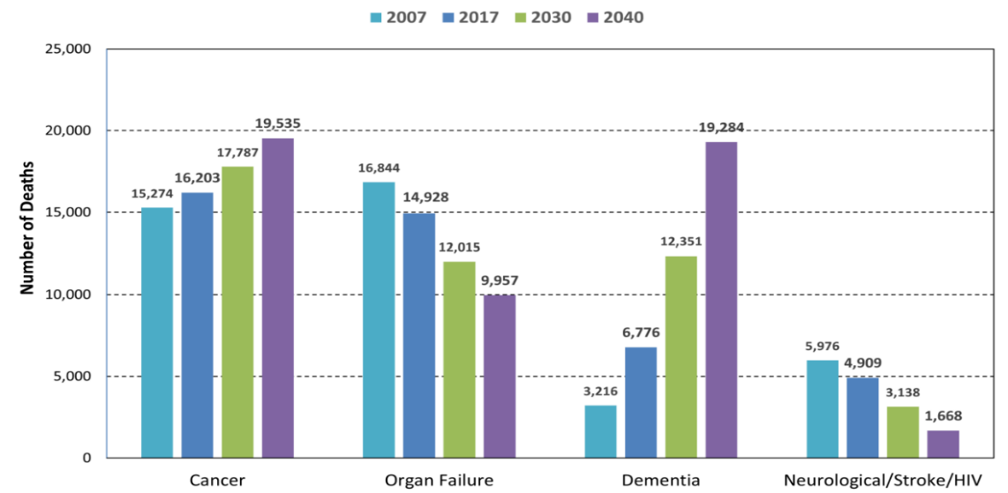

Data in the below bar chart shows where someone who lived in Forth Valley died in 2023. The chart covers all deaths within Forth Valley and the figures are percentages. As can be seen, 45% of citizens died in a hospital. We know that for most people they express a wish to die at home, or in a homely environment such as a care or nursing home, and these figures do not reflect that preference.
Location of death of Forth Valley residents - 2023
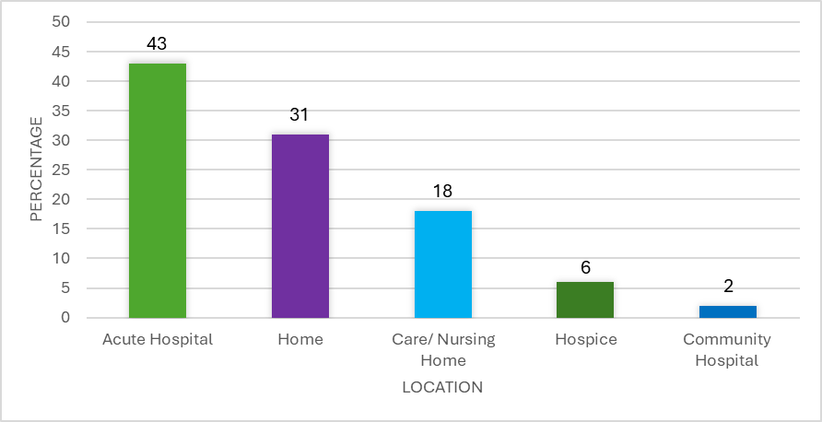

Q9: When looking at the impact on the equality groups, you must consider the following points in accordance with General Duty of the Equality Act 2010 see below:
In summary, those subject to the Equality Duty must have due regard to the need to:
- eliminate unlawful discrimination, harassment and victimisation;
- advance equality of opportunity between different groups; and
- foster good relations between different groups
Has your assessment been able to demonstrate the following: Positive Impact, Negative / Adverse Impact or Neutral Impact?
What impact has your review had on the following ‘protected characteristics’: | Positive | Adverse/  Negative | Neutral | Comments  Provide any evidence that supports your conclusion/answer for evaluating the impact as being positive, negative or neutral (do not leave this area blank)
Age | x |  |  | The two phases of consultation were open to all thus people of all ages were able to contribute their thoughts and views which influenced the drafting of the Strategic Commissioning Plan. Furthermore, the Plan outlines the strategic intent of what supported people can expect regardless of someone’s age.
Disability (incl. physical/ sensory problems, learning difficulties, communication needs; cognitive impairment) | x |  |  | The two phases of consultation were open to all thus people with a variety of conditions, or having cared for a loved one with specific conditions, were able to contribute their thoughts and views which influenced the drafting of the Strategic Commissioning Plan. Furthermore, the Plan outlines the strategic intent of what supported people can expect regardless of the condition(s) they are living with, to help define a consist approach to care and support despite someone’s disability.
Gender Reassignment |  |  | x | We are anticipating a neutral impact.
Marriage and Civil partnership |  |  | x | We are anticipating a neutral impact.
Pregnancy and Maternity |  |  | x | We are anticipating a neutral impact.
Race/Ethnicity |  |  | x | We are anticipating a neutral impact.
Religion/Faith |  |  | x | We are anticipating a neutral impact.
Sex/Gender (male/female) |  |  | x | We are anticipating a neutral impact.
Sexual orientation |  |  | x | We are anticipating a neutral impact.
Staff (This could include details of staff training completed or required in relation to service delivery) | x |  |  | Staff members were invited to and attended consultation sessions or completed the online surveys and input their thoughts and experiences, across both phases of the consultation. Their understanding of how others perceive their service, the skills they provide, what else is available as well as what could be improved, and the interplay between different care and support agencies have all helped shape and influenced the drafting of the Strategic Commissioning Plan. There are also specifically aims and outcomes drafted specifically for staff, taking account of the skills and coordination needed to complete their roles.

Cross cutting issues: Included are some areas for consideration. Please delete or add fields as appropriate. Further areas to consider in Appendix B
Unpaid Carers |  | x |  |  |  |  | The two phases of consultation were open to all thus carers were able to attend sessions in person, on complete the online surveys to have their voices and experiences relayed. Furthermore, their experienced have all helped shape and influenced the drafting of the Strategic Commissioning Plan, with specifically aims and outcomes drafted specifically for loved ones and unpaid carers.
Language/ Social Origins |  |  |  |  |  | x | We are anticipating a neutral impact. However, by setting out a vision, aims and outcomes it is hoped that it will be clearer what can be anticipated in terms of accessing palliative or end of life care and support.
Low income/poverty |  |  |  |  |  | x | We are anticipating a neutral impact.
Rural Areas |  | x |  |  |  |  | In recognition of more rural communities in Stirling, specific engagement events took place in Killin and Callender to ascertain the views of those living within these and surrounding communities.  It was clear that there are different experiences for those living in more rural parts of the Partnership, and as such the Strategic Commissioning Plan aims to have a consistent approach to care and support regardless of where someone chooses to live.
Third Sector |  | x |  |  |  |  | The two phases of consultation were open to all and thus third sector organisations were able to contribute their views. The consultation was also promoted by the Third Sector interfaces. As such, the views of the third sector have helped influence the drafting of the Strategic Commissioning Plan, especially as the third sector plays a key role in supporting people and their loved ones within the community.
Q10: If actions are required to address changes, please attach your action plan to this document. Action plan attached?
Yes |  |  | No
Q11: Is a detailed EQIA required?
Yes |  |  | No
Please state your reason for choices made in Question 11.

This approach is focussed on the strategic commissioning approach to palliative and end of life care in the community. Given the limited remit of this paper, and that it sets out high level principles for delivery, as opposed to defining new ways of working, a more detailed EQIA is not required.

A framework of legal rights and duties which underpin palliative and end of life care and support are listed below:
- The Equality Act 2010
- The Community Care and Health (Scotland) Act 2002
- The Human Rights Act 1998
- Adults with Incapacity (Scotland) Act 2000
- Adult Support & Protection (Scotland) Act 2007
- Social Care (Self-Directed Support) (Scotland) Act 2013
N.B. If the screening process has shown potential for a high negative impact you will be required to complete a detailed impact assessment.

Date EQIA Completed | 14/10/2024
Date of next EQIA Review | 14/10/2029
Signature |  | Print Name | Lisa Powell
Department or Service | Strategic Planning

Please keep a completed copy of this template for your own records and attach to any appropriate papers / proposals etc as a record of SIA or EQIA completed.

Send copy to fv.clackmannanshirestirling.hscp@nhs.scot for publication once approved.

B: Standard/Detailed Impact Assessment Action Plan
Name of document being EQIA’d:

Date | Issue | Action Required | Lead (Name, title, and contact details) | Timescale | Resource Implications | Comments

Further Notes:

Signed: |  | Date:

Ref: Finucane AM, Bone AE, Etkind S, et al. How many people will need palliative care in Scotland by 2040? A mixed-method study of projected palliative care need and recommendations for service delivery. BMJ Open 2021;11:e041317. doi:10.1136/ bmjopen-2020-041317

