**Clackmannanshire and Stirling HSCP 2024/25**

**Workforce Briefing No. 5**

**Highlights from the Transformation Progress Review meeting**

**05 November 2024**

Welcome to the fifth briefing from the Clacks and Stirling HSCP Senior Management and Leadership Team on our programme for savings and budget management through 2024/25.

As outlined previously these are challenging times. In response we are determined to deliver rigorous and sustainable change across health and social care services and by being more sophisticated about how we spend the money that is available to us.

Our pathway to transformation began with the identification of a series of priorities. These priority areas of work all now have agreed Business Justification Cases that include implementation milestones.

On a monthly basis, in advance of each meeting, project leads provide a status report that provides an overview of progress including:

* a brief summary of progress
* the project’s red/amber/green status
* milestones achieved in this month and to be achieved in the next
* an update on project risks, and
* details of any issues encountered, and any assistance required to maintain/regain control of the delivery of the desired project outcomes.
* estimated financial savings as far as possible – with project leads working with finance leads to support reporting and verify financial impacts

At the 5 November 2024 meeting progress on all of the areas of work was reviewed again and it was decided that this month the bulletin should provide a more focussed view of the good progress being made by the Care at Home Review Team.

The Care at Home Review Team is applying an asset based and outcomes focussed approach to reviews that is having both a positive impact on supported people and overall care costs.

Work in the early months has included ensuring that robust data is recorded to enable Review Team impact to be demonstrated. There are inevitably lag periods with recording and reporting this sort of data but alongside HSCP Data & Performance colleagues the Review Team can now report across a number of measures on a monthly basis.

The charts below show a snap shot of Care at Home Review Team impact up to the end of September ’24 and will be updated and shared with the Transformation & Savings meeting each month from here onwards.

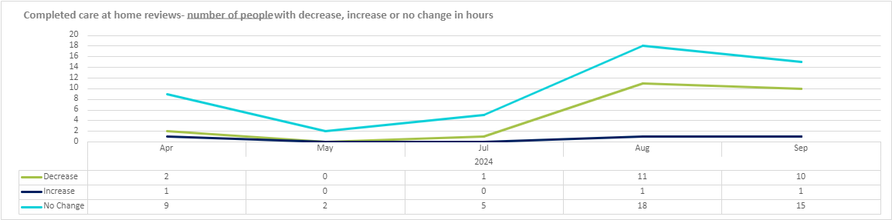

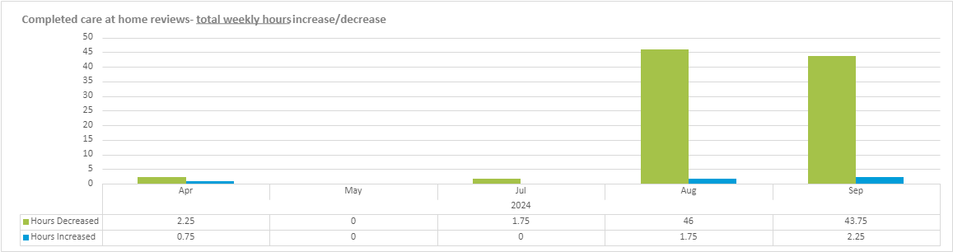





Ewan C. Murray

Chief Finance Officer